General Assembly (Singapore)
Data Analytics Bootcamp (DAB 11)
Topic: Driving Cost Efficiency in Digital Advertising

Prepared by Jiahong, Zhuo

Contents

Executive Summary 3

Overview 3

Data Information 4

Exploratory Data Analysis 5

Predictive Modeling 11

Recommendations 14

Appendix 16

Executive Summary
This report evaluates Apple’s digital advertising campaigns and finds that while most of them achieve relatively low cost per acquisition (CPA), certain markets such as France drive costs significantly higher, creating budget leakage. Stories advertisement type delivers the lowest CPA and strongest conversion performance, whereas video & image advertisement type are the least cost efficient. Geographic analysis shows that reallocating ad spending from high-cost markets like France and Mexico to more efficient regions such as the United States, Germany, and India reduce CPA and improve cost efficiency by more than 50%.
Improvements in users targeting validation are also needed to address a 78% mismatch between intended and actual user age groups. By implementing these recommendations, Apple can expect an 18% increase in purchase conversions with the same ad budget while more advanced ROI analysis is able to be performed once revenue data is incorporated in future datasets.

Overview

Audience
This report is prepared for client: Annie Chen (Senior Marketing Manager, Apple Inc.), John (Data Analytics Manager, D Advertising Pte Ltd). It is designed to provide actionable insights that support both client and internal decision-making.

Problem
Apple Inc. invests heavily in digital advertising, but cost efficiency varies across formats and markets. Inefficient capital allocation result in higher costs and weaker returns.

Goal
The report evaluates campaign performance against two criteria: achieving at least 10% increase in expected online purchases and/or 20% reduction in cost per acquisition (CPA) for each digital advertising dollar spent.

Approach
To address this challenge, the analysis examines user behavior across digital platforms and geographies, identifies inefficiencies, and recommends strategies for reallocating advertising budget. The goal is to guide Apple’s marketing team toward more cost-effective targeting of the right audiences, in the right locations, through the most efficient digital advertising channels.

Data Information
Data Source
The data is obtained from fictious advertising performance data from Kaggle. It covers from May to August 2025, including information regarding users’ profiles, advertisement campaigns, advertisement events such as clicks and purchases, as well as the budget and advertisement timings. The data was consolidated into a single dataset to ensure comparability across the various channels.

Data Cleaning
All the data records were cleaned to remove duplicates, incomplete entries and erroneous data points. Dates were standardized to a uniform format and numerical fields were validated against expected ranges. This ensured the dataset was reliable, consistent, and suitable for analysis.

Data Limitations
While the dataset provides robust insights into digital campaign performance, several limitations should be noted. Online sales data was not available, which a comprehensive digital advertising analysis is unable to be performed. The predictive modeling relied on a relatively short historical time period of four months, limiting the ability to capture longer-term seasonal trends. In addition, the low purchase rate of 0.5% limits the predictive modeling performance score as well. Audience segmentation was restricted by Kaggle, which may not fully reflect comprehensive customer behavior.

Exploratory Data Analysis

Purpose
This EDA section was carried out to discover key drivers of advertising performance, validating data quality and identify actionable patterns across different campaigns. This ensures stakeholders can trust the dataset and highlight early insights before advanced modeling stage.

Data Quality
There are approximately 1% of duplicated data which have been removed from the dataset. There are no missing data in the dataset, and dataset has been verified for reasonableness. The datatype of the various categories has been updated to the appropriate data types.

Key Insights
Figure 1. Advertising Event Types & Counts
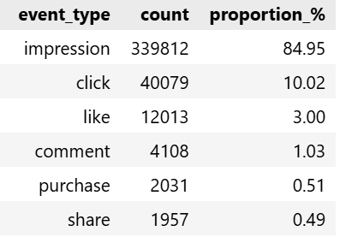

The number of impressions is the highest among all advertisement event types, making up approximately 85% of the total events (refer to above table). The second highest is number of clicks (10%) follow by number of likes (3%).

Figure 2. Histogram of CPA Cost by Age Group
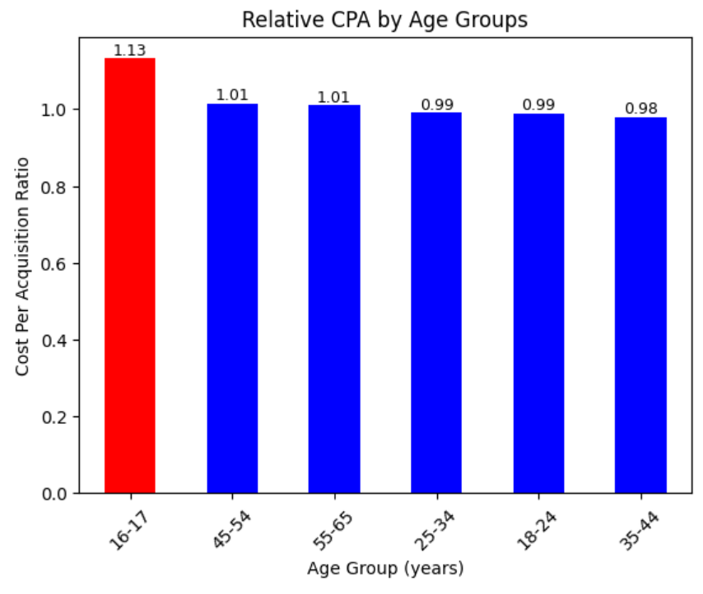
The above table shows that the majority of the digital advertising campaigns’ relative cost of acquisition (CPA) are below the median of 1 in the group. The users who are age 16-17 have relative CPA of 1.13 which is higher than that of the group median CPA of 1. This shows that most ads targeting users in most of the age groups are cost efficient except for ads targeting users between age 16-17. Hence, Apple should reduce the ads targeting the users for ages 16-17 to increase their ad cost efficiency.

Figure 3. Impressions & Advertisement Conversion Rate (CR)
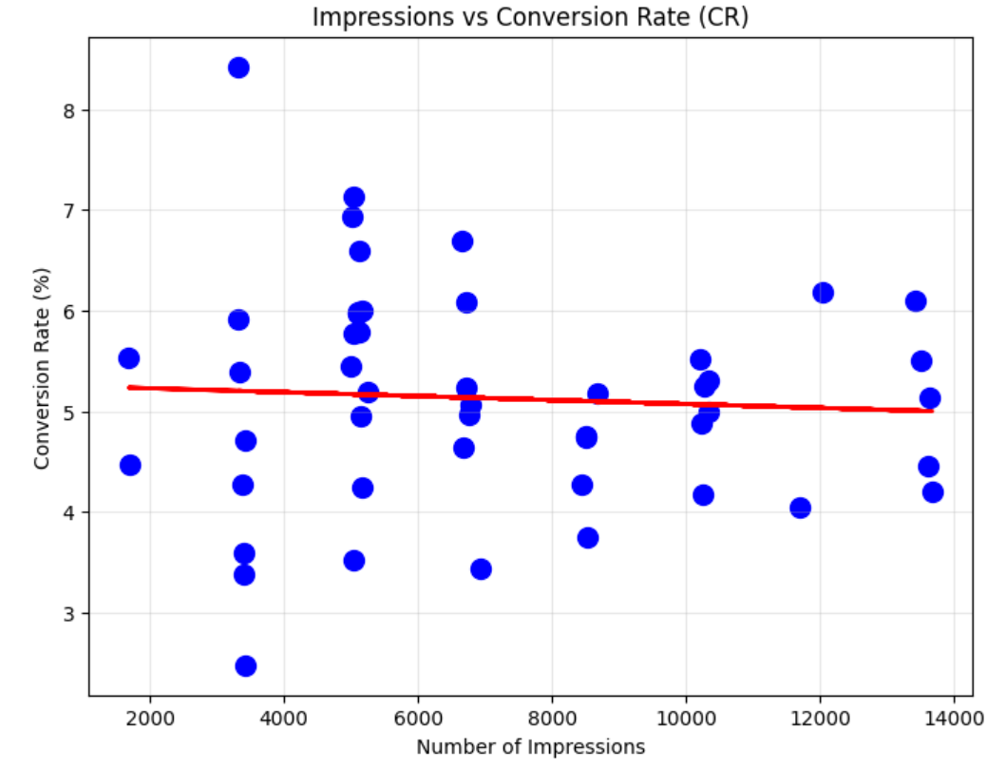
As shown from above figure, scaling ad impressions does not improve conversion rates (CR). The advertising conversion (purchase) rate ranges steadily from 3-6% regardless of number of impressions. This shows that businesses should capped their digital advertising budgets at current rates.

Figure 4. Relationship between Country & CR, CPA, CTR
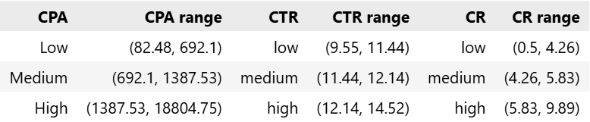

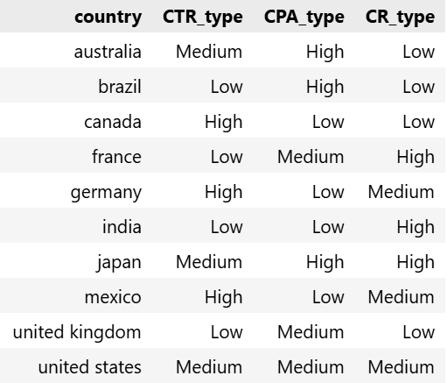

Based on the above figure, countries such as India, Mexico and Germany have low CPA cost, medium to high conversion rate (CR). Apple should allocate more advertising budget to these countries and reduce allocation to countries such as Australia and Brazil which have high CPA cost and low CR.

Figure 5. Relationship between CPA & Advertisement Type
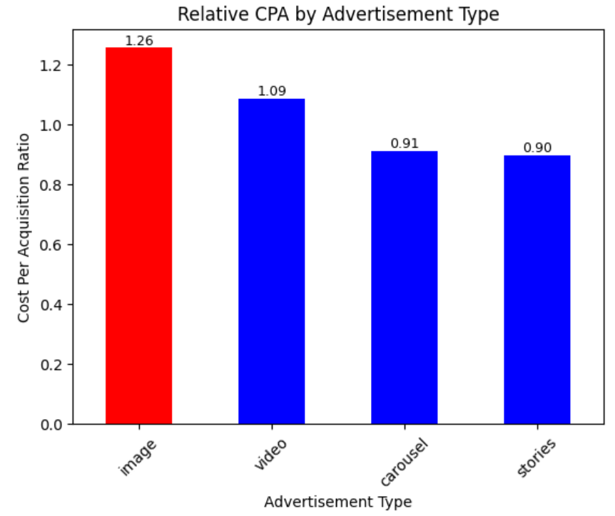
The relative cost of acquisition (CPA) per ad type is the lowest for Carousel and Stories advertisement types, and highest at 1.26 for Video advertisement type (refer to above figure). Hence, Apple should re-allocate advertising budget from image to carousel and stories advertisement types to be more cost efficient.

Figure 6. Mismatch of Target & Actual age groups
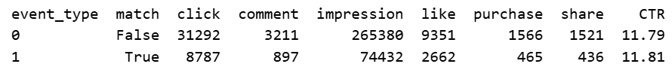
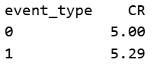

There is a high proportion (78%) of mismatch between target and actual age groups of online users. This means that any age group segmenting targeting strategy is most likely ineffective, even though the conversion (CR) and click through rates (CTR) of both groups (match = event type 1, mismatch = event type 0) are similar (refer to above table).

Outliers Detection
Figure 7. Relationship between Advertising Budget & CPA per ad
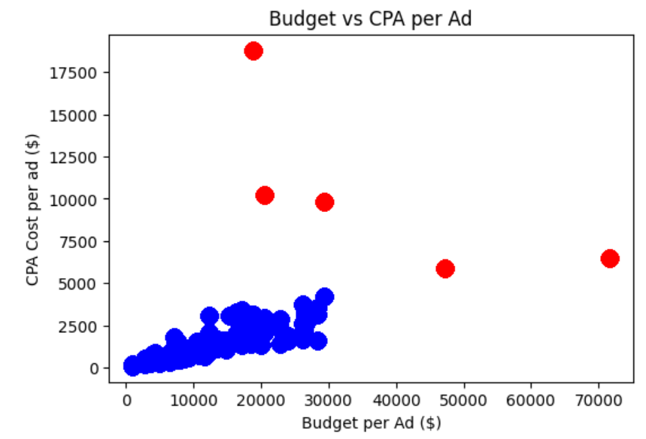
There is a small group of users whose CPA is significantly higher than the majority of the other online users (refer to red dots in above figure 7). Hence, they are the outlier group compared to other users. As such, median is being used to calculate averages in this report to exclude these outliers and better reflect the values of the majority of the population.

Correlation Analysis
Figure 8. Correlation between 4 categorical features
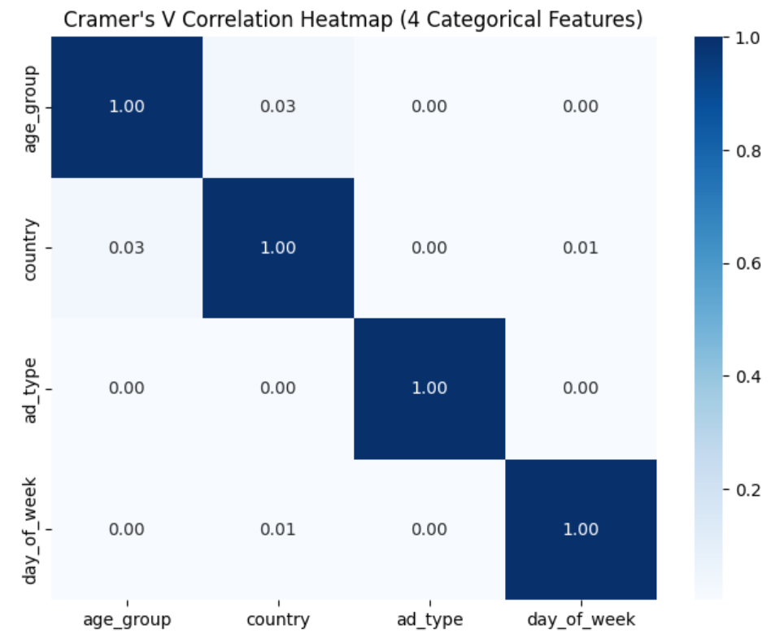

Figure 9. Correlation between Probability of Purchase & 4 categorical features

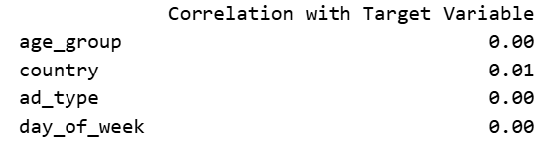
The correlations between the 4 categorical features (age group, country, ad type, day of week) and 2 numerical features (CTR, CPA) are very low of less than 0.1. In addition, the correlation between target variable and categorical features are also very low at 0.01 (see above). This shows that there is no multicollinearity issue among the features. However, these low correlations are also likely due to the low purchase rate (class size) of 0.5%.

Predictive Modeling

Model Rationale & Drivers
The logistic regression model is being chosen due to its ability to handle large datasets that consists of a mix of categorical and numerical features, as well as a binary target (purchase) variable. In addition, the model can train and predict faster and needing lesser computing power as compared to other similar models such as random forest.
There is a second model, Light Gradient Boost Model (GBM), that is used for the predictive modeling. Despite having a higher recall score, the extremely low and imbalanced F1 score of 0.01 will result in significantly higher number of incorrect purchase predictions, hence more wastage of advertising budget for Apple. In the end, the logistic regression model with a much higher F1 score of 0.34 is chosen due to its relatively lower wastage of advertising budget.

Figure 10. Coefficients & Odds Ratio of Logistic Regression Model
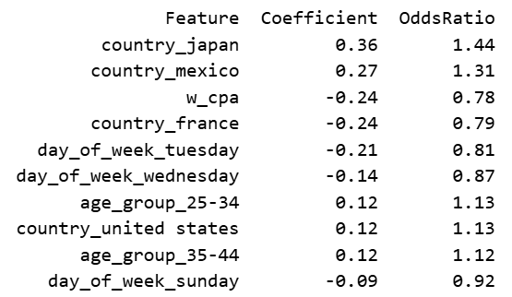

Features such as Countries and CPA are the strongest drivers of Probability of Purchase as shown from above table. Businesses should increase digital advertising targeting at countries like Japan and Mexico as every unit increase in these countries will result in an increase of 36% and 27% in the probabilities of purchase on the online users respectively. In addition, businesses should reduce the CPA as an increase in CPA will reduce the probability of purchase on the online users.

Performance Metrics
Figure 11. Logistic Regression Model Performance Metrics
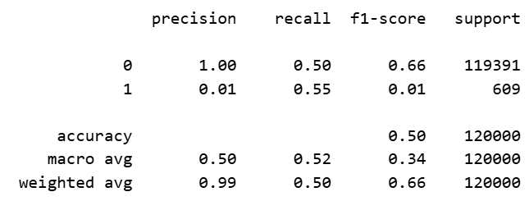
The logistic regression model achieves macro average performance scores (precision: 0.50, recall: 0.52, f1: 0.34, accuracy: 0.50) as per above table. These scores are not considered high, means the approximately half of the model’s predictions are true. The extremely low precision score of 0.01 for the minority class (1) is due to the low purchase rate of 0.5% (imbalanced class size).

Segment Analysis
Figure 12. Expected CPA by Country
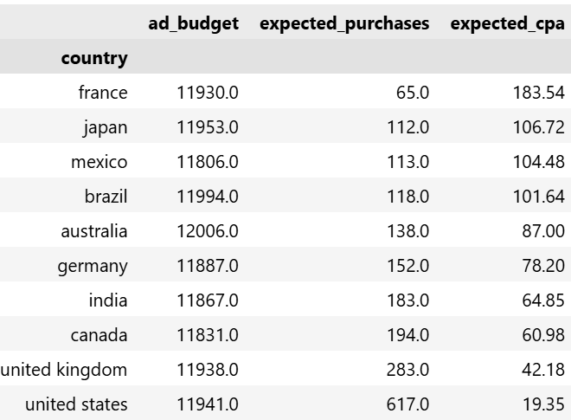
The top three countries with the lowest expected cost of acquisition (CPA) are United States ($19), United Kingdom ($42) and Canada ($61). The median expected cost of acquisition (CPA) of the countries segment is calculated to be $82.60. Businesses can re-allocate their digital advertising budget to focus on those countries whose CPA are below the median CPA cost.

Scenario Analysis
Figure 13. Increasing CPA by 10% on Probability to Purchase
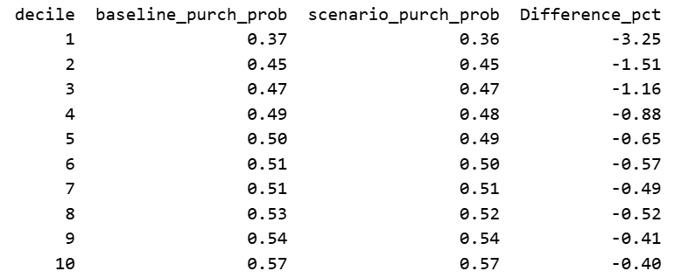
Increasing CPA by 10% will reduce the probability of purchase from -0.40% to -3.2% at every decile (refer to above) even though the overall mean probability to purchase is unchanged due to low purchase rate (0.5%). As such, this shows that businesses should reduce their average CPA in order to result in higher chance of purchase on their products.

Assumptions & Limitations
The above logistic regression model assumes that online users’ behavior patterns are representative of the behavior of the real world’s online users’ population, and market conditions will remain unchanged over time. Another assumption is that the target purchase variable is only linearly related to the features of the model, which are also assumed to be independent of each other.

There are several limitations, namely the low 0.5% purchase rate reduce model accuracy, making predictions less reliable. On top of that, the four-month time period of the dataset limits visibility of seasonal or long-term digital advertising trends. In addition, the absence of revenue data of advertisements limits the coverage of the digital advertising analysis. Last but not least, the high mismatch of the target group segments limits the value of the age group segment analysis.

Recommendations

Budget Allocation
Businesses can re-allocate 20% of their digital advertising spending from image advertising type (lowest expected number of purchases) to carousel and stories advertising type (highest expected purchases). This will result in a 18% increase in expected number of purchases (conversion) with the same amount of budget.
Furthermore, businesses can also re-allocate their digital advertising budget from high CPA cost countries such as France to countries that have high conversion rates and low expected CPA costs (United States, Germany & India). In this way, Apple should reduce their expected CPA more than 50%.

Data Improvements
Digital advertising revenue data should be included for more comprehensive analysis involving Return on Investment (ROI). In addition, longer time period data should be provided to allow for seasonality and longer-term advertising trends.

In addition, advertising companies like us should improve our target group data validation process to reduce the significant target age group mismatch issue. Consequently, businesses can deploy more effective age group segment advertising strategies.

Model Improvements
Due to the large imbalanced class size (purchase rate of 0.5%), the highest macro average precision and recall score of logistic regression model is only 52% which is not considered high. As a result, a second model, Light GBM, was being used and evaluated against the first model. Despite having a high recall score of 99%, its precision and F1 scores are very low 1% respectively.
This unbalanced recall-precision score of the Light GBM model leads to the conclusion that first model is more appropriate. More in-depth tuning of the model’s hyper parameters can be performed which may improve the performance scores of both models.

Next Steps
Apple should re-allocate 20% of digital advertising budget from Video to Stories ads to capture an 18% increase in conversions. A pilot reallocation from France and Mexico to the United States, Germany, and India should be tested over one month to confirm cost efficiency gains. Targeting validation must be strengthened to reduce the 78% age-group mismatch.

The dataset should be expanded to include digital advertising revenue data and longer time coverage to enable ROI and seasonality analysis. Predictive modeling should be refined with ensemble methods to balance recall and precision. Finally, monthly dashboards should be established to track CPA, conversions, and ROI to ensure sustained impact.

Appendix

Metric Definitions
Click Through Rate (CTR) = Clicks / Impressions * 100
Conversion Rate (CR) = Purchases / Clicks * 100
Cost Per Acquisition (CPA) = Campaign Advertising Budget / Purchases * 100

Data Dictionary Table
Field Name | Definition | Data Type
event_id | Unique identifier for each event | integer
ad_id | Unique identifier for each ad | integer
user_id | Unique identifier for each user | string
timestamp | Exact date and time when the event occurred | string
day_of_week | Day of the week derived from timestamp | string
time_of_day | Time bucket representing when event occurred | string
event_type | Type of user interaction | string
campaign_id | Unique identifier for each advertising campaign | integer
ad_platform | Platform where the ad was served | string
ad_type | Format of the ad | string
target_gender | Gender intended for targeting | string
target_age_group | Age group intended for targeting | string
target_interests | Interests intended for targeting | string
name | Campaign name or label | string
start_date | Campaign start date | string
end_date | Campaign end date | string
duration_days | Total campaign duration | integer
total_budget | Total allocated budget for campaign | float
user_gender | Gender of the user who saw the ad | string
user_age | Age of the user who saw the ad | integer
age_group | Age bucket of the user | string
country | Country where ad was served | string
location | Specific location (city/region) where ad was served | string
interests | Interests of the user who saw the ad | string

Tools & Environment
This report adopts SQL (structured query language) for joining of data tables. In addition, the report use python (pandas & scikit-learn) for data cleaning, exploratory data analysis, modeling and visualization for stakeholder reporting.

